# Guide to download and use the CGDA package in RStudio

## Install R

1. go to the following website: <https://cran.r-project.org/mirrors.html>

- Choose a location which is either your home country or close to your home country (in this guide, the Netherlands was chosen).

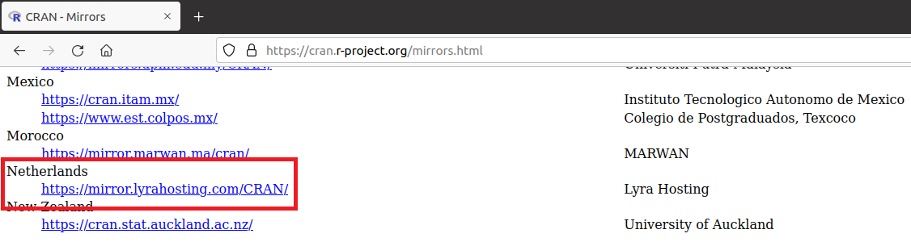

2. Dependent on the type of operating system you use, download R for either Linux, MacOS or Windows.

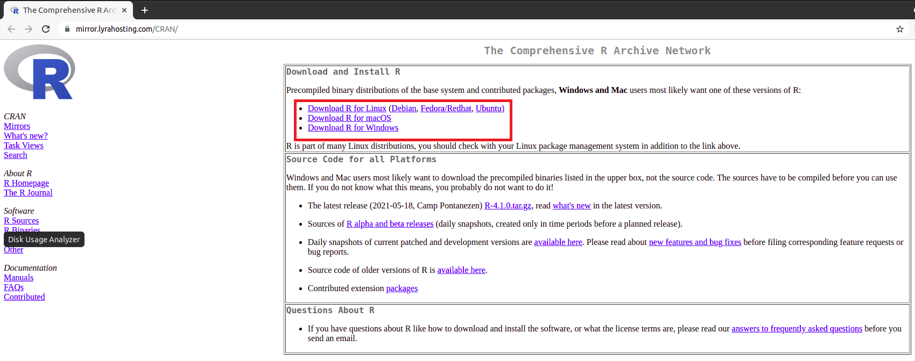

For Linux:

- Choose the Linux distribution you make use of.

- Hereafter, follow the guide for the respective Linux distribution to install R.

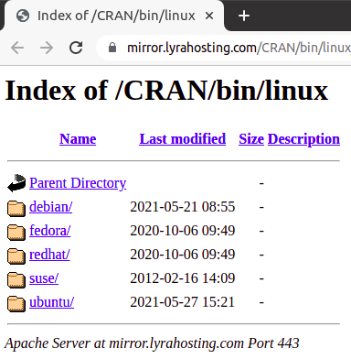

For MacOS:

- Download the latest release of R for MacOS.

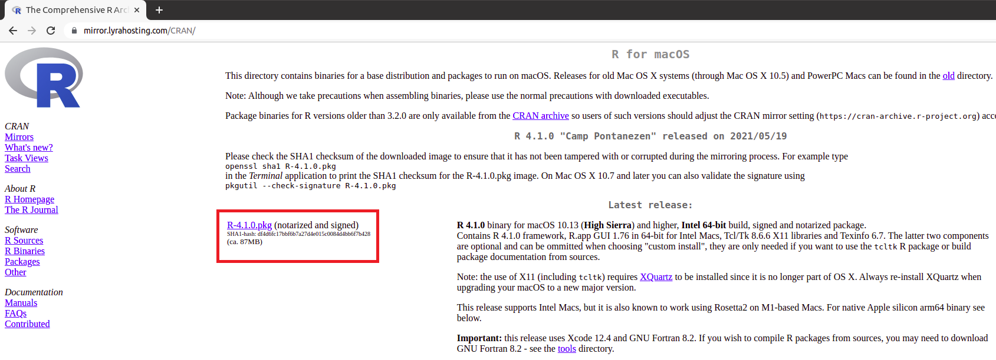

For Windows:

- After clicking on Windows, there is a subdirectorie in which is stated to install R for the first time. Click this. Then download R for Windows.

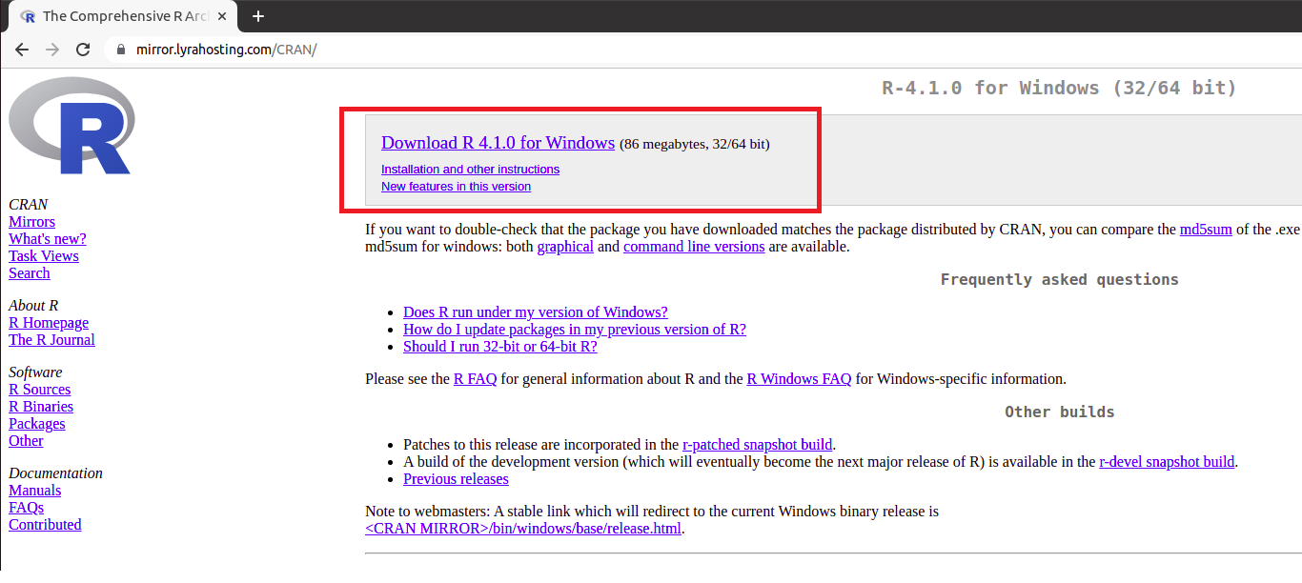

## Install Rstudio

1. Download RStudio Desktop at [https://www.rstudio.com/products/rstudio/download/#download](https://www.rstudio.com/products/rstudio/download/" \l "download).

- Choose the operating system you are working on and install RStudio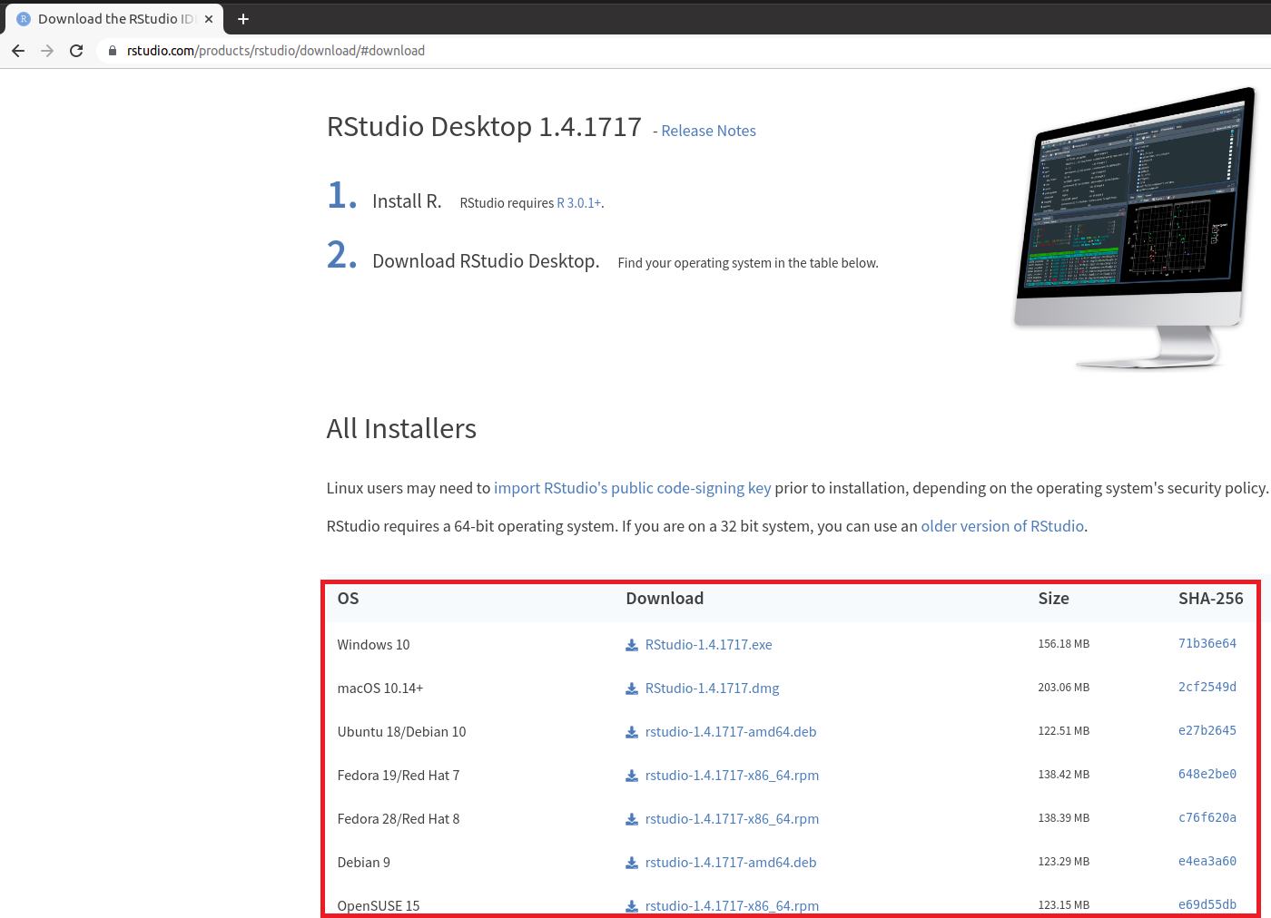

## Install the package in RStudio

The package can be installed in several ways. The most straight forward method is to install it directly from GitHub. However, one can also download the package first and then install it. Below are the two methods given.

Some of the useful tips:

* Within a script, you can run the whole script, or lines separately:
  + To run the whole script, you can select all and hit “control + enter” for Linux and Windows users or “command + enter” for MacOS users
  + To run a single line, your cursor needs to reside in this line and you press “control + enter” for Linux and Windows users or “command + enter” for MacOS users
* Within a script, you always start off with making your work-space clean so that no previous run or information (such as defined variables) intervenes



### First step

For both methods, there are a few steps to be taken in both cases. To install either from GitHub or locally by downloading the package, devtools needs to be installed in RStudio. This is done by typing “install.packages(“devtools”)”.



### Installing via GitHub

For simplicity, an additional R-script was created and placed in GitHub called “install_package_GitHub_guide.R”.

* Download and install the CGDA package directly from GitHub:

devtools::install_github(“EvdVossen/CGDA/CGDA”)



### Installing via downloading the package

For simplicity, an additional R-script was created and placed in GitHub called “install_package_local_guide.R”.

* Within RStudio, one needs to locate a path to where the package (and later on the data) is located:
  + Via getwd() one can see what the current working directory is



* + By specifying path (path <- **“/path/to/package/**”) followed by setwd(path). In our case, the path is “C:/CGDA”.

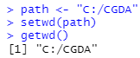

**Note that for some computers the path is specified with two reverse slashes (\\) instead of one forward slash (/)**

* Using list.files(); the filenames that are present in your current working directory will be listed



* After installation of devtools we can install the CGDA package
* Devtools::install_local(“CGDA_0.7.tar.gz”)



## Using the package in RStudio

Now that the package is installed, one can test it using the mock data present in Github. Make sure this mock data is downloaded to your local drive. An additional R-script named: “Test_CGDA.R” is also put on Github which makes use of the mock data.

As stated in the article, the CGDA package makes use of one main function called “cganalysis”. To find out more on the function, one can read the documentation on this function.

* First, activate the CGDA package



* Then type “?cganalysis” for the documentation



**Note when using groups, specify the names**

* subject_group_1 = c(“S1”, “S2”, “S3”, “S4”, “S5”)
* subject_group_2 = c(“H1”, “H2”, “H3”, “H4”, “H5”)
* subject_group_3 = c(“G1”, “G2”, “G3”, “G4”, “G5”)

**Also make sure that the number of subject_groups included (e.g. subject_group_1, subject_group_2, and subject_group_3) matches the number of group_names (e.g. group_names = c(“Group 1”, “Group 2”, “Group 3”)**